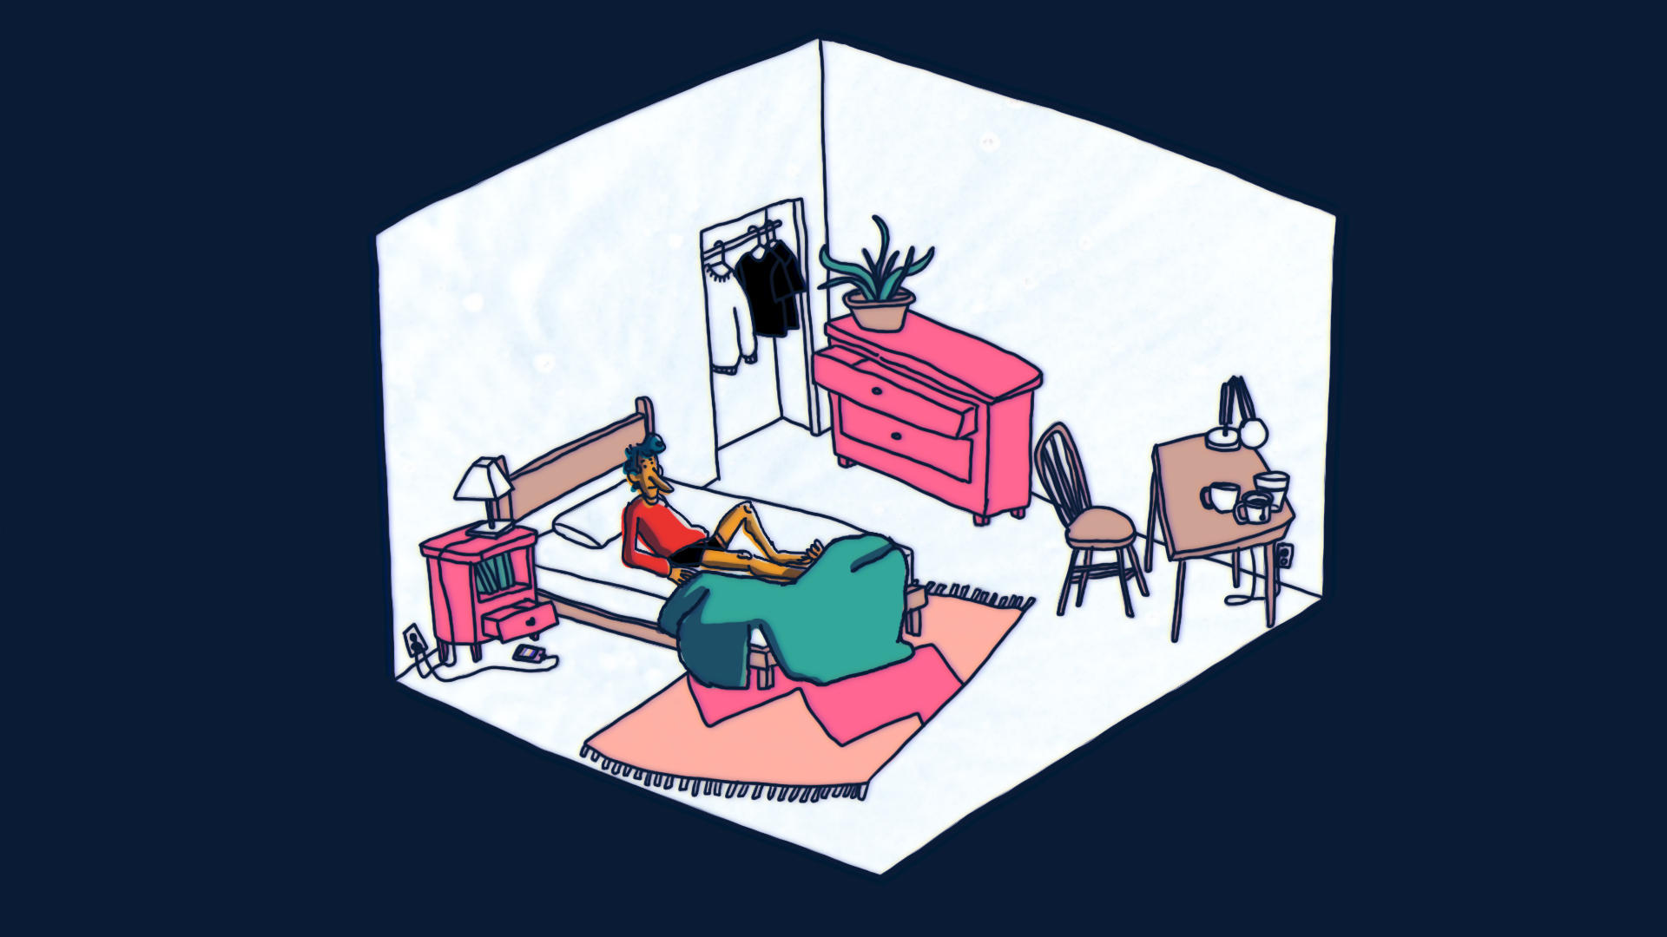

Title: HOLE
Director: Gil Goletski
Year Completed: 2018

Country of production: Canada
Duration/TRT: 6:03
Media: 2D digital, 2D traditional, Stop Motion, 3D
Film genre: Experimental comedy

Film Synopsis: Mo is an adult with Autism Spectrum Disorder. Mo spends a lot of time in their brain. Today, a hole started following them.

Website: goletski.com

Screening Formats
Movie formats: Quicktime, DCP
Compression: Animation, DCP, Apple ProRes
Frame ratio: HD Widescreen 16:9
Frame Rate: 24fps
Screen Resolution: HD 1080p
Audio: Stereo, Dolby 5.1

Contact & Distribution Information:
Contact: Gil Goletski
Mailing address: 1785 East 2nd Avenue, Vancouver, British Columbia
Email: ggoletski@gmail.com
Cell: (250) 218-4225

Canadian Filmmaker’s Distribution Centre: cfmdc.org

Film Credits:

Written and Animated by Gil Goletski
Colouring Assistants: Chris Strickler, Benjamin Buckley
Additional Compositing: Chris Strickler
Music: “Hole” by Gil Goletski, “International Waters” by Pale Red

Filmmaker’s Biography: gil goletski (b. 1995) is a multi-disciplinary artist living as a settler on the unceded traditional territories of the Musqueam, Squamish and Tsleil-Waututh people. they make animation, illustration, comics, print media, and music. they are currently a key member of the vancouver based animation collective, flavourcel.. Their film, HOLE, is the consummation of their experiences as a transgender person on the autism spectrum and their dissatisfaction with the ways in which medical and mental health services have failed people with disabilities.

Director’s head shot
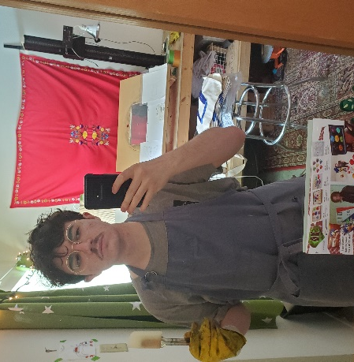
Gil Goletski, director

Film Production Stills

